Name: ________________ Fish310 Spring ‘14

Bivalve anatomy and classification

Mussels, oysters, clams, and scallops are members of a bivalve group formerly called the Lamellibranchia (now divided into Pteriomorphia, Paleoheterodonta, and Heterodonta). These animals use their ctenidia (gills) to filter tiny food particles such as bacteria, diatoms, unicellular algae, and detritus from the water. The particles are then transported by cilia along food grooves to sorting structures called labial palps and into the mouth. Members of this group have ctenidia with long filaments that fold back on themselves so that each row forms two lamellae (hence the name, Lamellibranch- “branch” means gill.) Lamellibranchs are separated into two groups based on the structure of their ctenidia:

- Filibranchs: or “thread gills”, include mussels, oysters, scallops and jingle shells. In this group the filaments making up the gill are attached to each other by ciliary tufts (think of it like interlocking hairs or Velcro). Bivalves of this group are often attached to hard substrates with byssal threads or cement.

- Eulamellibranchs: include clams and their relatives. Their ctenidial filaments are connected with tissue bridges. Members of this group often have very distinct inhalant and exhalent siphons and are often found buried in the sediment.

Part I: Filibranch Dissection
- Before you begin, carefully examine a cleaned mussel shell. In the space below draw the inside of the right valve and label the following features: umbo, hinge ligament, posterior adductor muscle scar, pallial line, and indicate the dorsal and ventral sides. (3)

- Examine the mussel shell closely and recall the three layers of a mollusc shell from lecture. Does the mussel shell have these three layers? How does it compare to a manila clam shell? (1)

Now obtain a live mussel. Locate the posterior and anterior ends, left and right valves, dorsal and ventral sides, hinge, umbo, and byssal threads.

To begin the dissection you must separate the right valve from the left valve. To determine the right valve from the left valve, hold the mussel so that the hinge is facing away from you with the flat edge of the shell against your palm. Note or label the right valve. The right valve is the one you will be removing from the animal!!

Hold the mussel in your hand with the right valve on top. Slip the straight end of a lab spatula into the byssal gape and twist it to force the valve open slightly. Now use your scalpel to cut the posterior adductor muscle (refer to your drawing of the muscle scar to find the location). Slip the blade into the posterior gape and cut the muscle, it will be the only firm, resisting structure in the vicinity. Try to avoid cutting any other tissues around the muscle.

Cut the anterior adductor muscle, located just short of the anterior tip of the shell. Lift the right valve slightly and use the lab spatula to scrape the right mantle lobe from the valve. Separate the right valve from the left valve (it may be necessary to cut the black tissue connecting the two valves).

Discard the right valve and place the left valve with the animal contained in it in a dish adding enough cold seawater to cover the animal. Examine the mantle lobes which line the inner surfaces of the valves. Note how the mantle lobes are connected dorsally to each other and to the body but are unattached elsewhere.

Posteriorly the right and left mantle lobes together form the inhalant and exhalant siphons of the mussel. Neither of the two siphons is distinct. Rather, they are modified areas of the mantle margin.

- Based on the structure of the shell and the siphons of the mussel would you expect to find them deeply buried in the sediment? Explain. (0.5)

Mussels are somewhat unusual among bivalves in that they have very thick mantles that contain much of the gonad. When ripe, the mantle of males is creamy beige while that of females is orange.

- What sex is your mussel? Put a tiny piece of gonad on a slide in a drop of water and look at it with one of the compound scopes. Are there motile sperm or distinct eggs? (0.5)

Use scissors to remove the right mantle lobe and expose the right ctenidium and mantle cavity. There is only one gill on each side even though it looks like there are two. The entire gill is a holobranch (“whole gill”) and it consists of two demibranchs (or half gills): a lateral (outer) demibranch and a medial (inner) demibranch. Each of the two surfaces of the demibranch is a lamella. In a cross section the holobranch can be thought of as a capital W. The area where the ctenidium is attached to the body wall is represented by the middle point of the W. Each V of the W is a demibranch and the lamella are the four straight lines that compose the W. The two lamella that drop from the middle are the descending limbs (/\) and the two that rise back up into the mantle cavity are the ascending limbs (\ /). In filibranchs the upper ends of the ascending lamella are entirely free, not attached to the body wall.

- Label the simplified filibranch diagram below with the following features: (1)
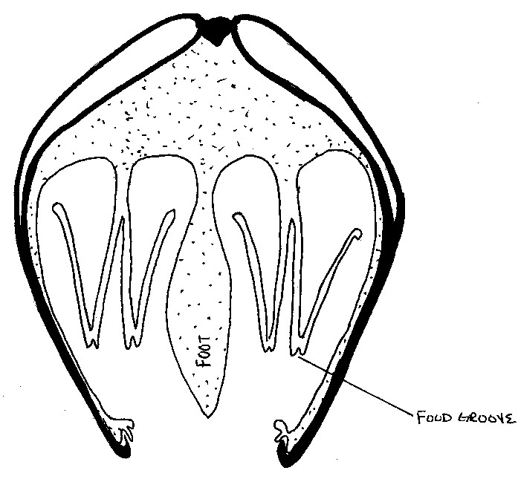
ascending limb
descending limb
holobranch
outer demibranch
inner demibranch
central axis

- Fill in the blanks: In a filibranch there are a total of (number) ______ holobranchs, ________ demibranchs, and __________ lamella. (0.5)

Identify the mouth, labial palps, and foot of the mussel. Put the mussel and the dish under a dissecting scope and examine the ctenidia closely. Place a very tiny droplet of food coloring along the bottom edge of the gills and observe the movement of water. Now drop a small amount of yeast on the surface of the gills and watch the path of the particles over the gills.

- On one diagram below trace the path of food/particles as they travel along the gills and through the body, and on the other trace the path of water as it moves through the body. (1)

WATER MOVEMENT FOOD PARTICLES
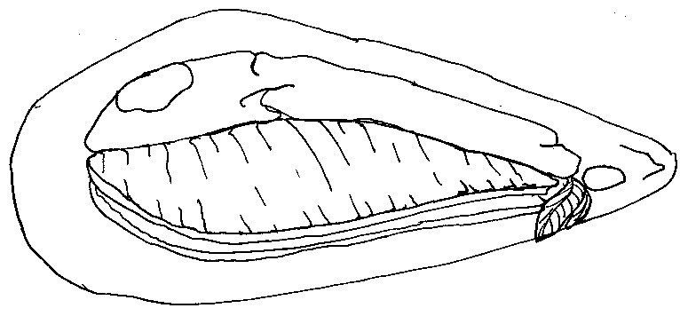
- How is the movement of water and food particles accomplished? (0.5)

- Explain the function of the labial palps and the fate of non-food particles that are trapped on the gill surfaces with food particles (be sure to include the terms pseudofeces, labial palps, and food grooves). (1)

Using the compound scope, examine the surface of the right lamellae and the numerous very narrow gill filaments. The filaments are held together by ciliary tufts so can be easily pulled apart for a wet mount.

- Draw what you see. Can you see ciliary action? (1)

Remove the right gill to expose the visceral mass, which is the major part of the body and contains most of the organs. The large dark brown digestive gland comprises much of the mass and pretty much conceals the intestine and stomach.

Try to locate the byssal gland at the base of the foot. You may be able to see some byssal threads emerging from the byssal gland.

Remove the skin covering the dorsal side to expose the heart. The frilly brown organ associated with the heart is the pericardial organ, involved in excretion. You may see tiny orange or red structures; these are the cerebral ganglia.

- Sketch your specimen below, labeling the following features: visceral mass, left ctenidia, foot, byssal gland, byssal threads, digestive gland, labial palps, posterior adductor muscle, anterior adductor muscle, left mantle, heart. (3)

There are several differences between clams (eulamellibranchs) and mussels (filibranchs), some of which are visible in the dissected clam in the plastic block. In clams, the edge of the ascending lamellae (the \ and / of the W) are attached to the body. Note the large, blade-like foot, clams use for digging in the sediment. The clam’s right and left mantle lobes also join together across the midline to form two distinct siphons. The inhalant siphon is the ventral one and the exhalant siphon is the dorsal one.

- What advantage is there to this distinct inhalant/exhalant siphon design as compared to that of the mussel? (1)

As with the mussel, the clam gill is made up of filaments. However, clam gill filaments are held together by tissue rather than cilia; these interfilamental tissue junctions completely and firmly attach adjacent filaments together. The surface of the clam gill lamellae are also formed into ridges.

- What advantage is there to having ridged gills? What advantage is there to having attached lamellae instead of ciliary tuft connections? (1)

- Compare the shell of a filibranch bivalve to that of a eulamellibranch. Are there any general trends or differences between the animals in these two groups?(consider both shell composition and morphology) (1)

15. Examine the shells representing the following different families of bivalves and try to discern what distinguishes each group (list the distinguishing features). Remember that features in the hinge area are often very important. (4)

You should be able to recognize and give the common name of the taxa listed below.

Veneridae: hardshell clams

Pectinidae: scallops

Mytilidae: mussels

Ostreidae: oysters

Hiatellidae: geoduck

Tridachnidae: giant clams

Anomiidae: jingle shells

Teredinidae: shipworms

