Name: ______________________

Class Gastropoda

The gastropods are the most diverse class of molluscs and include marine, freshwater, and terrestrial snails and slugs. Gastropods generally have a large foot, 1- 2 ctenidia, 1-2 osphradia, and a distinct head with 1-2 pairs of tentacles. Most are secondarily asymmetrical and have a spiraled shell and visceral mass. All undergo torsion early in their development, though some (e.g., nudibranchs) then become ‘de-torted’.

Subclass Pulmonata

Pulmonates include land snails and slugs and are among the most highly derived of the gastropods, because of the conditions they have had to overcome to survive in a terrestrial habitat. Pulmonates have no gills; instead the interior of the mantle cavity is vascularized and functions as a lung. The opening of the mantle cavity has been reduced to a small pore called the pneumostome.
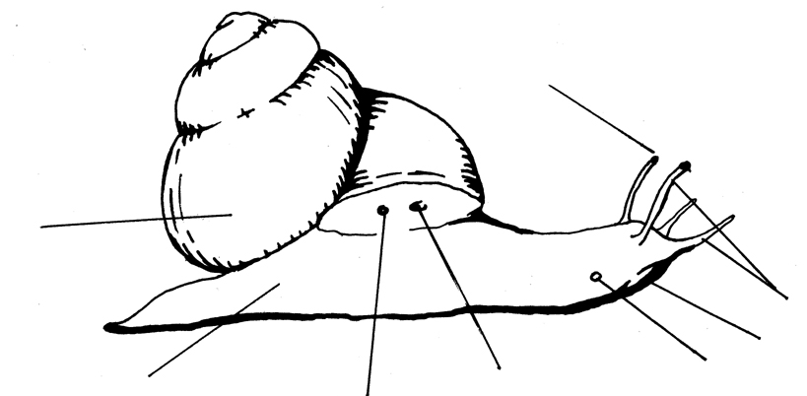
eye

shell

pneumostome
anus
gonopore
foot
mouth
tentacles

Place a land snail (Helix) on a slide with some flour, and carefully turn the snail and slide upside down. Using your dissecting scope, observe the movement of the radula.

- Describe how Helix uses its radula to feed. (1)

Subclass Opisthobranchia

The opisthobranchs are gastropods that have undergone detorsion, and most belong to the Order Nudibranchia- the sea slugs. In most of these animals the regular gills (ctenidia) have been lost and in many, dorsal extensions called cerata serve both as part of the digestive system and also as respiratory surfaces.

- Since they lack a protective shell, nudibranchs must rely on other methods of defense. Name 2 different ways that nudibranchs avoid or deter predators. (1)

- Examine the different species of nudibranchs. Draw your favorite and label the following (where applicable): rhinophores, cephalic tentacles, gills, mouth, and cerata. How are nudibranchs different from terrestrial slugs? (2)

Subclass Prosobranchia

The prosobranch gastropods include the majority of marine snails, among them conches, cones, cowries, limpets, murexes, periwinkles, volutes and whelks, as well as numerous freshwater groups, and some land snails with an operculum. The operculum is a thick plate situated on the dorsal surface of the foot. In many prosobranchs, the snail can completely close the aperture with the operculum when the body is retracted into the shell.
The term prosobranch is a reference to their anatomy and development, and means "gills in front of the heart". This is in contrast to the term opisthobranch, which means "gills to the right and behind the heart."

The shells on the front table are a miniscule sampling of just a few of the many families of marine snails. By the time we finish with molluscs, you should be able to recognize the orders and suborders these families belong to.

Examine the three orders Vetigastropoda, Patellogastropoda, and Caenogastropoda (suborders Mesogastropoda and Neogastropoda) and get a feel for the general features of each group. Although these divisions are in part based on differences in soft anatomy (e.g., number of gills; structure of osphradium), there are overall patterns in the form of the shell.

- Name at least one shell feature that seems to define these groups. (2)

Vetigastropoda:

Patellogastropoda:

Caenogastropoda:

Mesogastropods:

Neogastropods:

- For each unique feature listed above describe why this characteristic would benefit the animal? Think about adaptive advantages as well as disadvantages. (2)

Place a live neogastropod in a dish with seawater under your dissecting scope. Impale a small bit of mussel tissue on a probe and hold it in front of the snail. Try to get the maximum extension of the proboscis.

- How long is the proboscis relative to the length of the shell? (1)

- Draw your neogastropod in its fully extended position in the space provided below. Label the anterior and posterior ends, the head, eye, tentacles, foot, operculum, siphon, and proboscis. (2)

Gently prod your neogastropod so that it fully withdraws into its shell. The structure now blocking the aperture (opening) of the shell is the operculum.

- How does its material of the operculum compare to that of the shell? (1)

Class Cephalopoda

The cephalopods (Phylum Mollusca) are an ancient and highly specialized taxa with ~700 species. Included in the Class Cephalopoda are: octopus, squid, cuttlefish, and nautilus. Members of this taxa are all marine and most are pelagic (except the benthic octopus).

- Examine the dissected squid. Draw a picture of the squid and locate the following parts: lateral fins, funnel, tentacles, arm, suckers, main heart, branchial heart, gills, beak, and ink sac. (2)

- Briefly describe the function of the following features: (2)

a. Lateral fins:

b. Funnel:

c. Tentacles:

The cephalopod orders Teuthoidea (squid) and Sepioda (cuttlefish) no longer have an external shell; it has been reduced to an internal structure called a pen in squids and cuttlebone in cuttlefish.

- Observe the cuttlebones- What purpose does this structure serve? (1)

- Compare the paper nautilus to the chambered nautilus. How do they differ? What is the function of each? (1)

- What structures are in the brown box? What is their function? (1)

- Look at the preserved octopus and squid. Name some morphological differences you see. (1)

