1/7/09 L1 - Tissue Extraction I
- Select tissue previously archived in ultra-cold freezer
Selected black abalone digestive gland tissue preserved in Liq N2 and stored @ -80C
sample # 08:13-4 from 2nd (mini) WS resistance study
TL:
TW:
SW:
Sample date:
Sump/Tank: Sump 1 (Exp)/2E (SNI)
Notes: Active but not attaching, bloated – histo positive for weird (protest?) bug
SEX: female
Histo Score:

- Start RNA extractions (add Tri-Reagent to samples and re-freeze)
Samples extracted in duplicate in case of error and also for replication

RNA ISOLATION PROTOCOL
*important to use extreme sterile technique when handling RNA
1. Turn on heating block to 55C. Also turn on spectrophotometer.
2. Add 500uL of TriReagent *caution: contains phenol* to a 1.5mL snap cap tube. Store on ice.
3. Using a clean razor blade, cut a piece of frozen tissue weighing between 50-100mg and add to tube containing TriReagent.
Tissue sample R1 = 63mg
Tissue sample R2 = 50mg
4. Carefully homogenize the tissue using a disposable pestle.
5. Add an additional 500uL of TriReagent to the tube and close the tube.
6. Vortex vigorously for 15s.
----- Stop here for Lab 1 and freeze sample at -80 - Will continue extraction in Lab 2

- Extract protein from complementary sample

PROTEIN EXTRACTION PROTOCOL
*important to use extreme sterile technique when handling proteases
1. Add 0.5mL of CelLytic MT solution to a 1.5mL snap cap tube.
2. Add 25mg of your tissue to the tube.
Tissue sample P1 = 32mg
Tissue sample P2 = 31mg
3. Homogenize the tissue with a disposable pestle.
4. Close the tube and invert the tube several times.
5. Spin the tube in a refrigerated microfuge for 10mins. @ max speed.
6. While spinning, label a fresh tube with the word "Protein", source organism/tissue, your initials, and today's date.
7. Carefully transfer supernatant to labeled tube and store tube on ice.
8. To a fresh tube, add 1.5mL of Bradford reagent. Note: The Bradford assay works best when samples are mixed well. Invert tubes frequently during incubations, and immediately before measuring absorbance to ensure accurate absorbance readings.
***Also add a control tube (1.5ml Bradford and 30uL CelLytic MT solution) to “zero” out absorbance readings and account for any variations due to the CelLytic MT solution.
9. To this same tube, add 30uL of your protein extract.
10. Invert the tube several times and then incubate at RT for 10mins.
11. Mix the tube several times and transfer 1mL to a plastic, disposable cuvette.
12. Measure the absorbance at 595nm and record the value.
P1 = 1.542 OD
P2 = 1.571 OD
(OD = optical density = absorbance)
13. Remove the cuvette from the spectrophotometer. Using a P1000 set to 1mL, carefully pipette the solution in the cuvette up and down a couple of times to mix.
14. Measure the absorbance at 595nm and record the value.
P1 = 1.541 OD
P2 = 1.568 OD
15. Repeat steps 13 and 14.
Did not perform b/c values were almost identical
16. Average the three absorbance values you recorded.
P1 Avg = 1.5415 OD
P2 Avg = 1.5695 OD
Note: Coomassie Blue dye in Bradford reagent absorbs at 595nm and the absorbance can be directly correlated to a specific amount of protein present in the sample when compared to a standard curve (already determined for us).

Standard curve was generated as per Manufacturers Instructions.
Pierce: Coomassie (Bradford) Protein Assay Kit
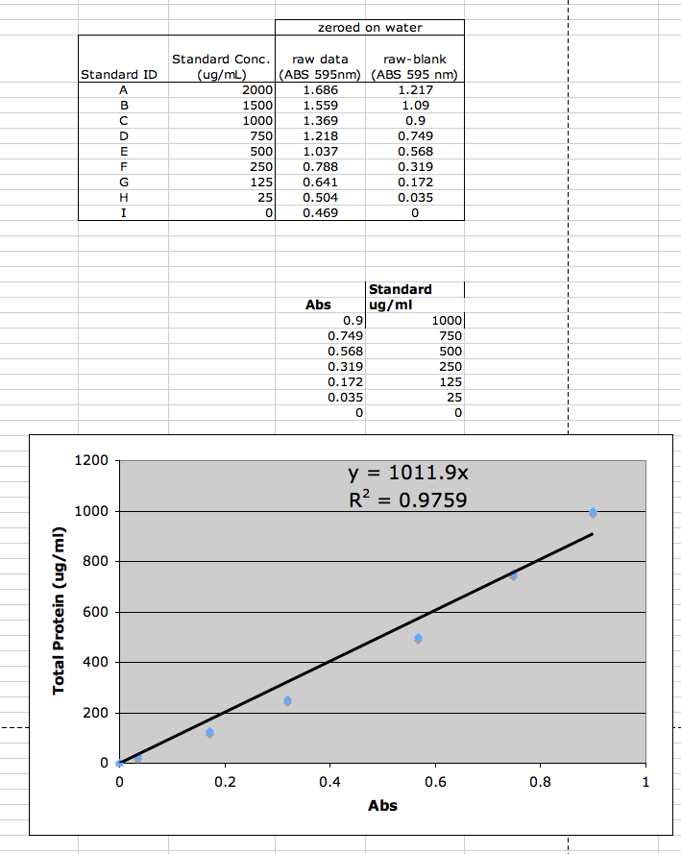
17. Plug your average absorbance that you just calculated into the following equation y=1011.9x to determine the concentration of protein in your sample. NOTE: It appears all of our protein values were outside of the curve. Need to dilute an aliquot of samples and run again.
18. Write the concentration on your tube (forgot to do this) and place tube in TA ice bucket. Sample stored at -80C.

- Design / order Primers to use in Lab 3

Check PGN recognition protein

