Normalizing gene qPCR primers O. lurida

1. **EF1A_METHJ Elongation factor 1-alpha**

Sequence:

>filtered_2000_NoIndex_L007_R1_trimmed_contig_15253

GTAGCAGAGTGAGATGTTCTGATGTAACAAGTTGGAGAGTAACCAACGGAAAGAGGTCCA

GGAAGAGTCAAAGTTTGGATCATAGCAGTGATTTTCTTTGCTGGGATAACAGAGTTATCG

TTCTTGAAAACCATAATATCACCCTTCTTTGGCATATTATCCTTGTTCAAACCCTTCATG

TTGATACCAATGTTATCTCCAGGAATAGCTTGTTCATAATTCTTGTGATGCATTTCAATG

GTGAAAACCTTACCGAGGCAAGGGTTTGCAGCAG

Forward: TCCTTGTTCAAACCCTTCATGT

Reverse: CAAACCCTTGCCTCGGTAAG

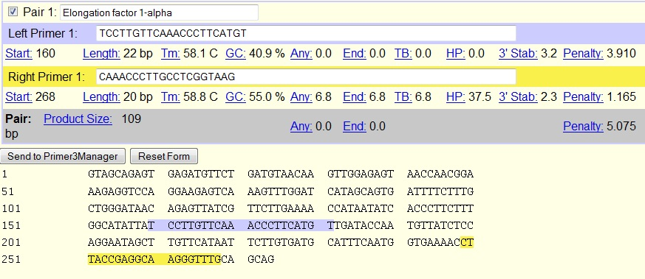

1. **G3P_ONCMY Glyceraldehyde-3-phosphate dehydrogenase**

Sequence:

>filtered_2000_NoIndex_L007_R1_trimmed_contig_20372

CTAGCCGAATGGTAACGAGAGCTCGCTGGGTTGTTGTAGGGGGGGTGTTAAGCTTGCGCT

AGAATTTTTTGNNGTCCAGCCTGAAGGTTGTTAAGAAAAAGGTGGTTGCCTAGACTAGAA

AGGTGAGTGCCGTCAGGGCGGAACAAGTGAAGGTTTGAGTGGTGGATATTGTGGTCATGG

TCAATGTAATGACCCTGGACTTCAGAGGCCATAAACTCCCGCATAATTTTGTTGACCCTG

ATGCGTTTTTTGTTGATTTTGGGTGCATGTTCTAGAGAGACATGGTGCCAGTATCGGCGA

GTAAGTAAGCTGGACCAGACAAGTTTGGTTCTTGGCCATAGAGCATTGTACCTATATAAT

GTACATTGTACGGTGTGTGTAAATGTTTTGGAGGAAGTGTCAGAAACAAGATCGTTAGNN

CCCACATGGAACAAGATGCAATCGGGGGCGGGGGCTTTTTCAGCCATGTTAGTGATGGTA

TCCTGCACTTGTCTCCACTTGAGTCCCCTGATGCCGTTCCAAGTGATCCTAGCAGGTAGG

TTAAGATTTGCCCCCCCTGGTCTCTGCTGTGCAGCCAGCCCCGCCCAGTAAG

Forward: AGAAAGGTGAGTGCCGTCAG

Reverse: ATGCGGGAGTTTATGGCCTC

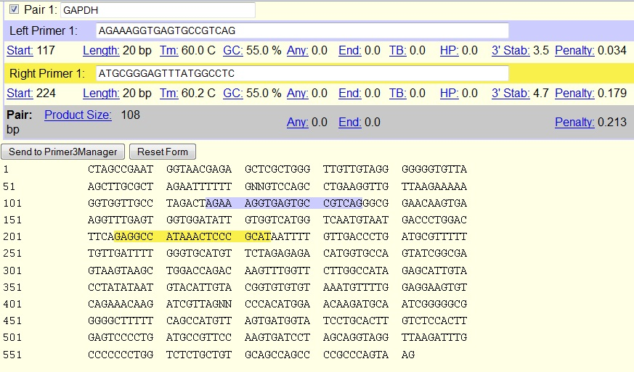

1. **ACT_PLAMG Actin, adductor muscle**

Sequence:

>filtered_2000_NoIndex_L007_R1_trimmed_contig_477

CTCTCTGGTGGGGCAATGATCTTGATCTTCATGGTGCTTGGAGCAAGAGCGGTGATTTCC

TTCTGCATACGGTCAGCAATACCTGGGAACATGGTGGTACCTCCGGAGAGGACGGTGTTG

GCGTACAGATCCTTACGGATGTCGACGTCGCACTTCATGATGGAATTGTAGGTGGTTTCA

TGGATACCAGCAGATTCCATACCCAAGAAGGATGGCTGGAAGAGGGACTCTGGGCAACGG

AATCTCTCGTTACCGATGGTGATGACCTGACCGTCGGGAAGCTCGTAGCTCTTCTCGAGG

GAGGAAGAGGAAGCGGCGGTGGCCATTTCCTGCTCGAAGTCGAGGGCGACATAGCAGAGT

TTCTCCTTGATGTCTCTGACGATCTCTCTCTCGGCGGTGGTTGTGAATGAATAACCACGC

TCGGTGAGGATCTTCATGAGGTAGTCAGTAAGATCACGACCAGCCAAATCCAGACGAAGG

ATAGCGTGGGGAAGGGCGTAACCTTCGTAGATGGGGACAGTGTGGGTGACACCATCACCG

GAGTCAAGCACGATACCAGTGGTACGACCGGAAGCGTACAGGGACAGCACGGCCTGGATG

GCAACGTACATGGCGGGAGCGTTGAAGGTCTCGAACATGATCTGTGTCATCTTTTCTCTG

TTGGCCTTGGGGTTGAG

Forward: GACCAGCCAAATCCAGACGA

Reverse: CGGTCGTACCACTGGTATCG

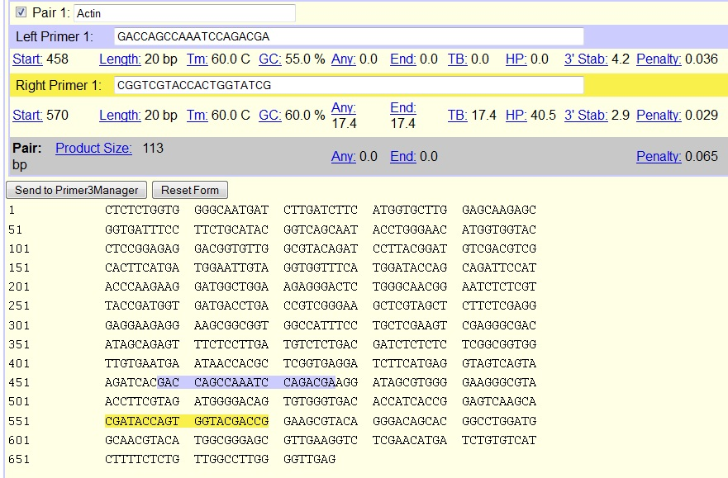

1. **RLA0_RANSY 60S acidic ribosomal protein P0**

Sequence:

>filtered_2000_NoIndex_L007_R1_trimmed_contig_857

TTTTTTTTTTTTTTTATTTCACTTTTTATTCAGTATCCTTTGCCATATGGTGTGAACAAC

CGGCATGGAATACTATCCGATGAGAATCCTTATTGTCATCAAGCCGTTAGTCAAACAGTC

CAAAGCCCATGTCATCGTCAGACTCGGACTCTGGCTCGGGTTTCTTCTCCTCTTTCTTCG

CTGGGGCGGCGGCAGCGGCAGAAGCTGCAGGTGCGGCTGCTGTTGCAAACTTGCTGGGGT

CCTTCAGGTACTCCTTAGTCTTCTCGGCCTCAGGGAAACTGTAGTCCGTTTCCACGGCAA

TAGCAAGCAGCCTCTTGAATCCGTTGGCAATGCAGTGGGGAGCGGAGGCTGCAGTTGGGT

AACCAATGGCTAAGGACAGGGCAGCAATGTTTCTCACTCCCTGCATGAACTTATCCCGAA

TATCTTCATCAGTAATGTCCAAAATTTGTGGCTCAAAAATGGTTCCAGAGTCATACACTT

TTTCAATGAGAAGTCCGTAGGAAAATGGAGAGATGCCCAACATGTTGAGGAGAGTGGATT

CGGAAGACCCCACCCTGTCACCAGCTTTAATCAGGTGAACTTCGTTCAAGATTTCAATGC

ATCCTCTGGTAATCTTGGTGGGGATCTGCAGAGCTTGGAAGAAGGAGGTCTTCTCAGGTC

CCAGTGTGGTGGCCTGGGCAGGCACCTTGACATCTAGGGGAGCAAGGGCACCTGCTTTTG

CTGGTGCTTTTACCTTGTTGGCCAGGAGAAGGTCTCTAGTCTCCACCAGCTCACCCTTCA

AAAACACCAAGCCAATGTTGTTCTTAATATGGGGCAGAAGTCTTTCCAAAAGTGGGTTTT

TTTCCATGTGGCCTCTGATGGCTTTTCGCATCATGGTATTTTTCCCCATCAACACAATGG

CTTTATTTCGCAGGGCCTGACGGATCTGCTGCATCTGTTTTGATCCAACATTATCAGCAT

TCACAATGAAGGCTTTTGGGTATTCATCTAACAGGCTTGATATTTTCAAGAAGTAGTTTG

ACTTCCAGGTGGATTTGTCTTCCTTGACCATCTTGCTGTGGCACAGGGATAGCTATAAAC

GCAGTTTAAAGACAAACCGGAAACGTGTTCAGCGCAAAGAGAGAGACCACG

Forward: AGGAGGTCTTCTCAGGTCCC

Reverse: GAGACCTTCTCCTGGCCAAC

