**Xenopus laevis insulin-like growth factor 1 receptor (igf1r)**

e-value: 2E-121

NCBI Reference Sequence: NM_001088265.1

OL contig 16699

Primers: product: 101bp

Left: CTTCCTTCCCGAACAGGTCC – 20bp, Tm: 60C

Right: GGAAGTGGAGCGTGACAAGA – 20bp, Tm: 60C

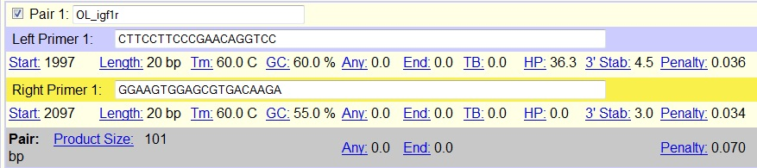

**Bos taurus U2 small nuclear RNA auxiliary factor 1-like 4 (U2AF1L4)**

e-value: 6.00E-84

NCBI Reference Sequence: NM_001034778.1

OL contig 2634

Primers: product: 130bp

Left: GACGTAGCAGGAGTCGTAGC – 20bp, Tm: 60C

Right: GCCTCGACTCAGTATCTGCC – 20bp, Tm: 60C

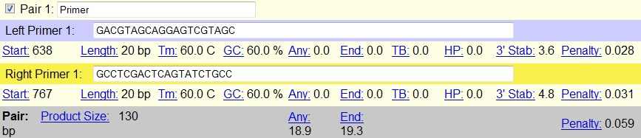

**Bos taurus protein kinase, cGMP-dependent, type I Ol_(PRKG1)**

e-value: 0

NCBI Reference Sequence: NM_212821.1

OL contig 6017

Primers: product: 105bp

Left: ACGGGCTGGGATAGAGACTT – 20bp, Tm: 60C

Right: CTCGCATTCTGTTGTAGCGC – 20bp, Tm: 60C

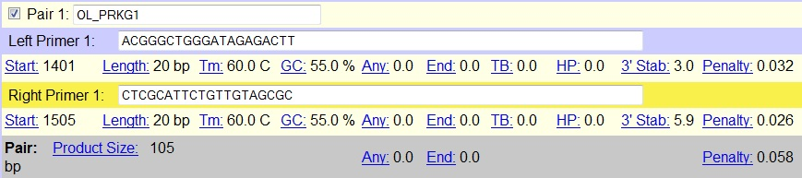

**Danio rerio cysteine rich transmembrane BMP regulator 1 (chordin like) (crim1)**

e-value: 3.00E-38

NCBI Reference Sequence: NM_212821.1

OL contig 6017

Primers: product: 112bp

Left: CAGGAGAGTGCTGTCCAGTG – 20bp, Tm: 60C

Right: TCTGGACCTCTCTCTGCCTC – 20bp, Tm: 60C

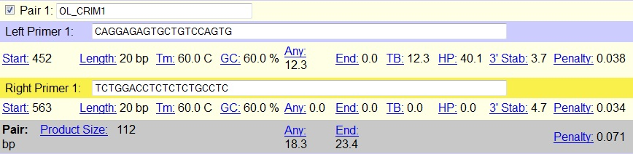

**Bos taurus BCL2-associated athanogene 2 (BAG2)**

e-value: 6.00E-18

NCBI Reference Sequence: NM_001034264.1

OL contig 28500

Primers: product: 101bp

Left: TGAAGCCATGGCGGAAAGAT – 20bp, Tm: 60C

Right: TCACTTTGTCCAGAGCTGTCTC – 22bp, Tm: 60C

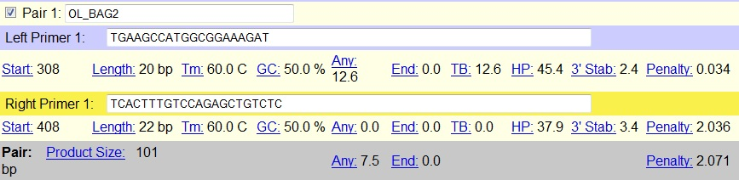

**Homo sapiens heat shock protein 90kDa alpha (cytosolic), class B member 1 (HSP90AB1)**

e-value: 0

NCBI Reference Sequence: NM_007355.2

OL contig 392

Primers: product: 149bp

Left: GTCACGCTCTTTCTCCACCA – 20bp, Tm: 60C

Right: GCACTATGGGTCGTGGAACA – 20bp, Tm: 60C

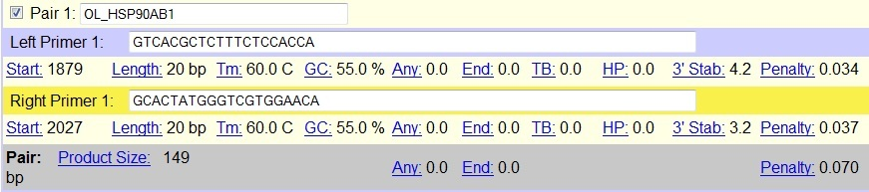

**Mus musculus muscle glycogen phosphorylase (Pygm), mRNA**

e-value: 0

NCBI Reference Sequence: NM_011224.1

OL contig 152

Primers: product: 131bp

Left: TCACCAGTGTTGCCAAGGTT – 20bp, Tm: 60C

Right: GATCTGCTCACTCAGGTCCG – 20bp, Tm: 59.9C

