Gel Image
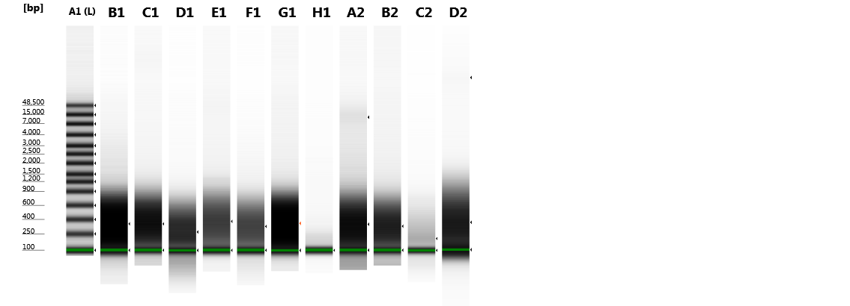
gDNA
Contrast: 0.50

Sample Info
Well | Sample Description | Alert | Observations
A1 | Ladder | ! | Ladder; Caution! Expired ScreenTape
B1 | 023 | ! | Caution! Expired ScreenTape
C1 | 035 | ! | Caution! Expired ScreenTape
D1 | 036 | ! | Caution! Expired ScreenTape
E1 | 031 | ! | Caution! Expired ScreenTape
F1 | 032 | ! | Caution! Expired ScreenTape
G1 | 103 | ! | Caution! Expired ScreenTape
H1 | 104 | ! | Caution! Expired ScreenTape
A2 | 105 | ! | Caution! Expired ScreenTape
B2 | 106 | ! | Caution! Expired ScreenTape
C2 | 108 | ! | Caution! Expired ScreenTape; Sample concentration outside recommended range
D2 |  | ! | Markers outwith standard running position; Caution! Expired ScreenTape

A1  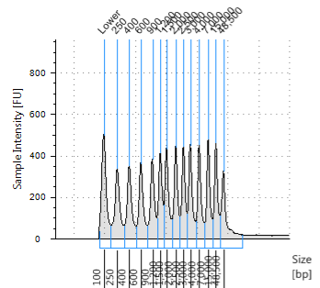  Ladder | B1  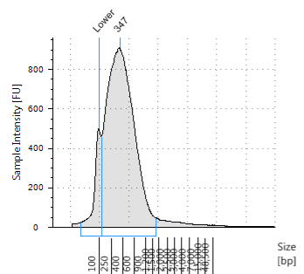  023 | C1  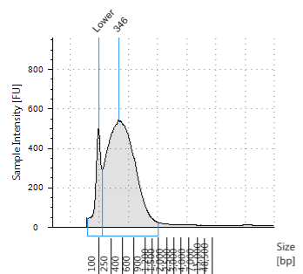  035 | D1  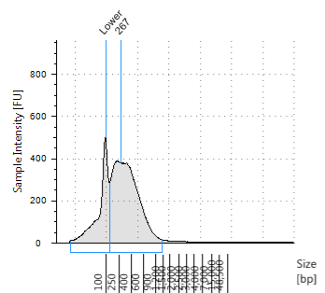  036
E1  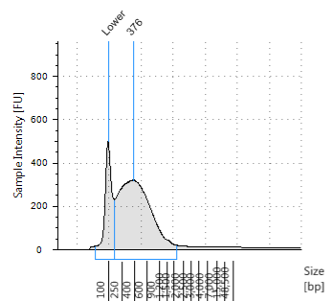  031 | F1  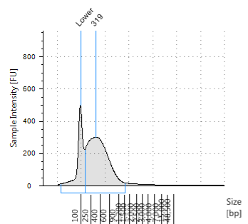  032 | G1  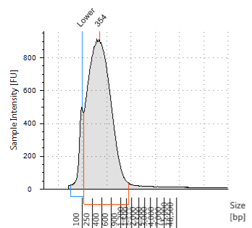  103 | H1  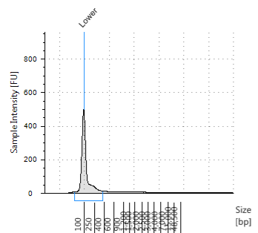  104
A2  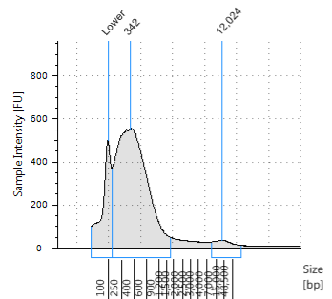  105 | B2  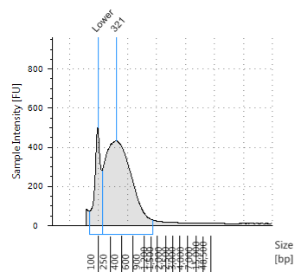  106 | C2  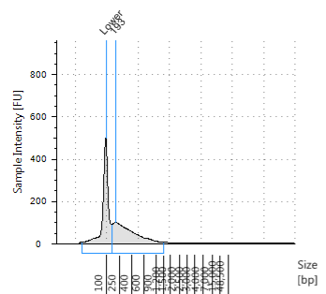  108 | D2  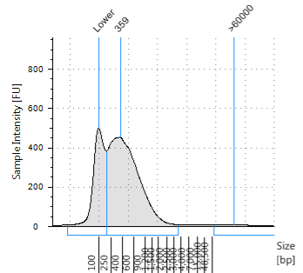

A1
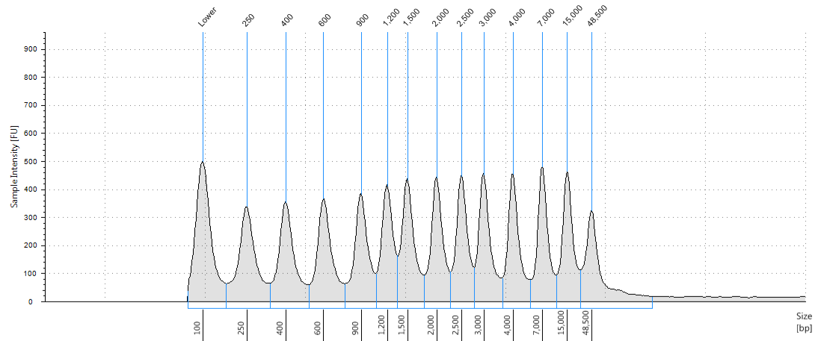
Ladder

Peak Table
Size [bp] | Calibrated Conc. [ng/µl] | Assigned Conc. [ng/µl] | % Integrated Area | Peak Comment | Observations | From [bp] | To [bp]
100 | 8.50 | 8.50 | - |  | Lower Marker | 74 | 162
250 | 6.23 | - | 8.37 |  |  | 162 | 331
400 | 5.88 | - | 7.89 |  |  | 331 | 513
600 | 5.73 | - | 7.69 |  |  | 513 | 756
900 | 5.61 | - | 7.53 |  |  | 756 | 1,057
1,200 | 5.29 | - | 7.10 |  |  | 1,057 | 1,342
1,500 | 6.11 | - | 8.20 |  |  | 1,342 | 1,772
2,000 | 5.82 | - | 7.81 |  |  | 1,772 | 2,267
2,500 | 5.57 | - | 7.48 |  |  | 2,267 | 2,765
3,000 | 6.02 | - | 8.09 |  |  | 2,765 | 3,598
4,000 | 5.61 | - | 7.53 |  |  | 3,598 | 5,531
7,000 | 5.66 | - | 7.60 |  |  | 5,531 | 10,747
15,000 | 5.50 | - | 7.38 |  |  | 10,747 | 22,492
48,500 | 5.36 | - | 7.20 |  |  | 22,492 | >60000
- | - | - | - |  | Sample Well | - | -

B1
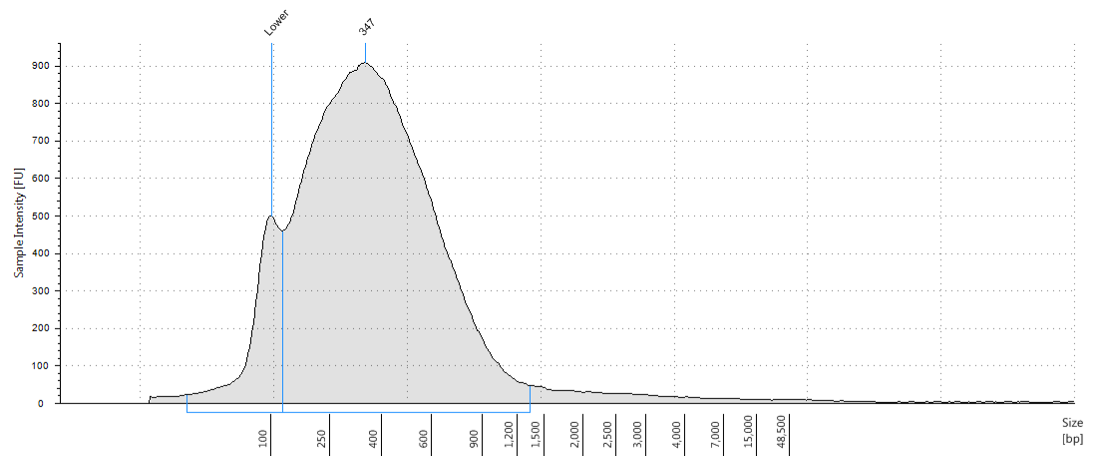
023

Peak Table
Size [bp] | Calibrated Conc. [ng/µl] | Assigned Conc. [ng/µl] | % Integrated Area | Peak Comment | Observations | From [bp] | To [bp]
100 | 8.50 | 8.50 | - |  | Lower Marker | 27 | 120
347 | 70.4 | - | 100.00 |  |  | 120 | 1,338

C1
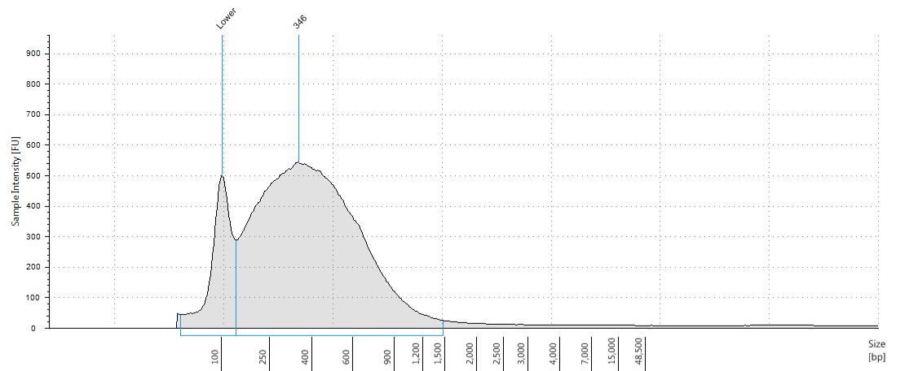
035

Peak Table
Size [bp] | Calibrated Conc. [ng/µl] | Assigned Conc. [ng/µl] | % Integrated Area | Peak Comment | Observations | From [bp] | To [bp]
100 | 8.50 | 8.50 | - |  | Lower Marker | 45 | 132
346 | 48.8 | - | 100.00 |  |  | 132 | 1,481

D1
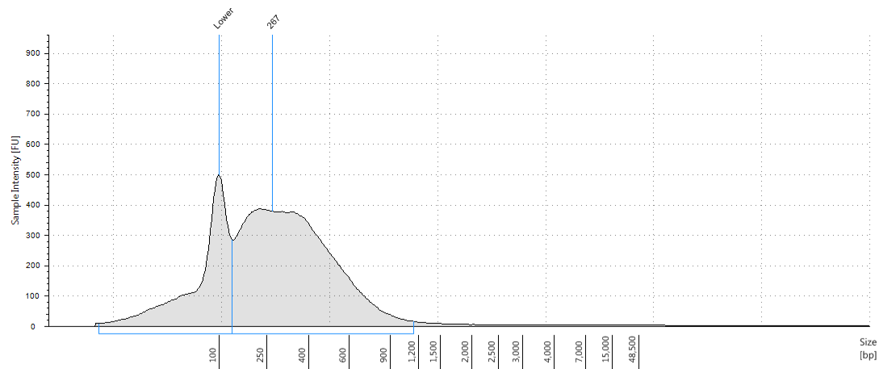
036

Peak Table
Size [bp] | Calibrated Conc. [ng/µl] | Assigned Conc. [ng/µl] | % Integrated Area | Peak Comment | Observations | From [bp] | To [bp]
100 | 8.50 | 8.50 | - |  | Lower Marker | 10 | 130
267 | 21.2 | - | 100.00 |  |  | 130 | 1,145

E1
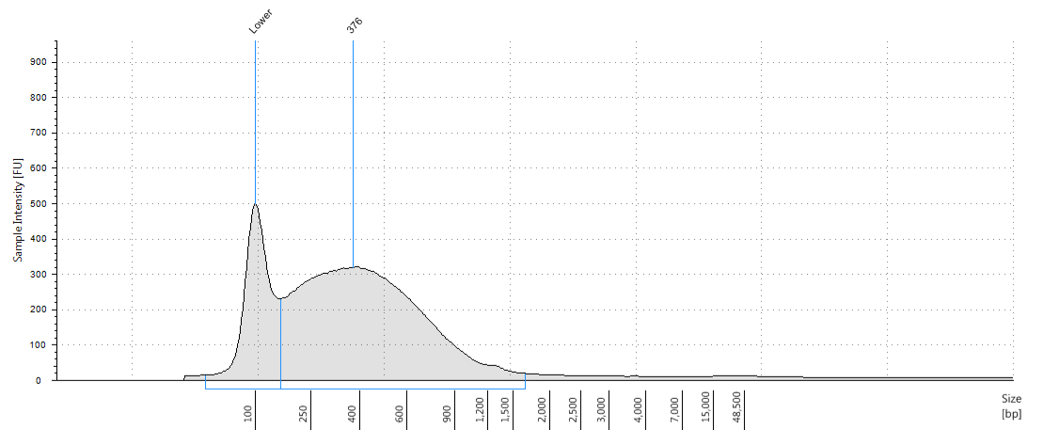
031

Peak Table
Size [bp] | Calibrated Conc. [ng/µl] | Assigned Conc. [ng/µl] | % Integrated Area | Peak Comment | Observations | From [bp] | To [bp]
100 | 8.50 | 8.50 | - |  | Lower Marker | 43 | 151
376 | 27.1 | - | 100.00 |  |  | 151 | 1,652

F1
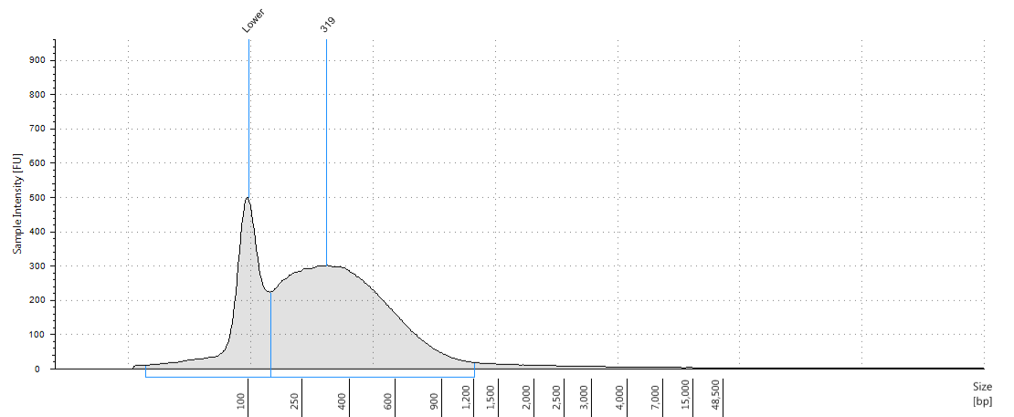
032

Peak Table
Size [bp] | Calibrated Conc. [ng/µl] | Assigned Conc. [ng/µl] | % Integrated Area | Peak Comment | Observations | From [bp] | To [bp]
100 | 8.50 | 8.50 | - |  | Lower Marker | 17 | 145
319 | 21.3 | - | 100.00 |  |  | 145 | 1,214

G1
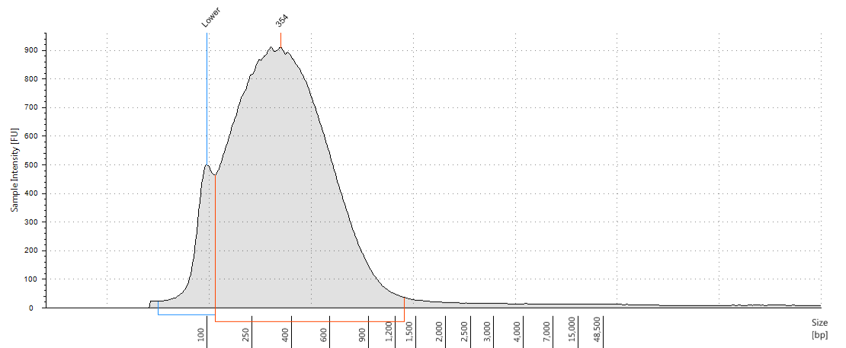
103

Peak Table
Size [bp] | Calibrated Conc. [ng/µl] | Assigned Conc. [ng/µl] | % Integrated Area | Peak Comment | Observations | From [bp] | To [bp]
100 | 8.50 | 8.50 | - |  | Lower Marker | 37 | 118
354 | 82.8 | - | 100.00 |  |  | 118 | 1,326

H1
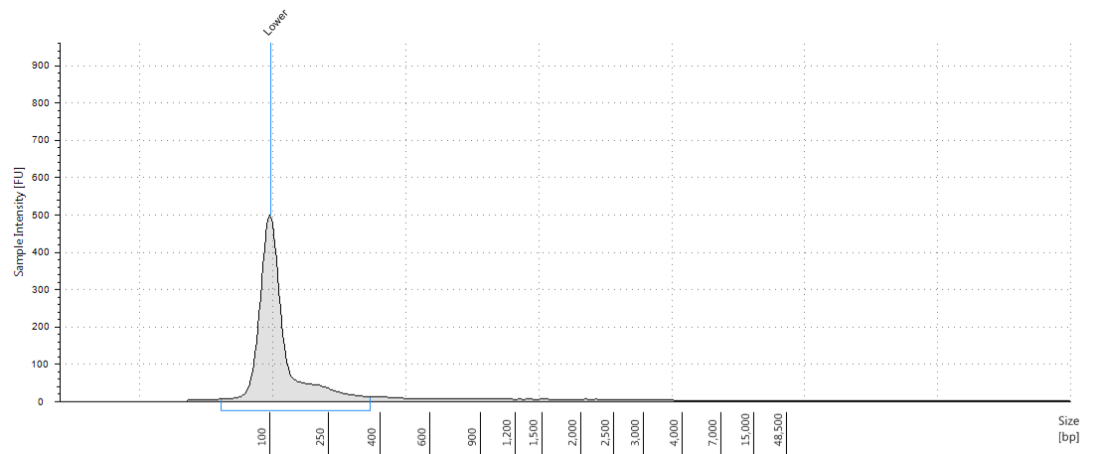
104

Peak Table
Size [bp] | Calibrated Conc. [ng/µl] | Assigned Conc. [ng/µl] | % Integrated Area | Peak Comment | Observations | From [bp] | To [bp]
100 | 8.50 | 8.50 | - |  | Lower Marker | 46 | 365

A2
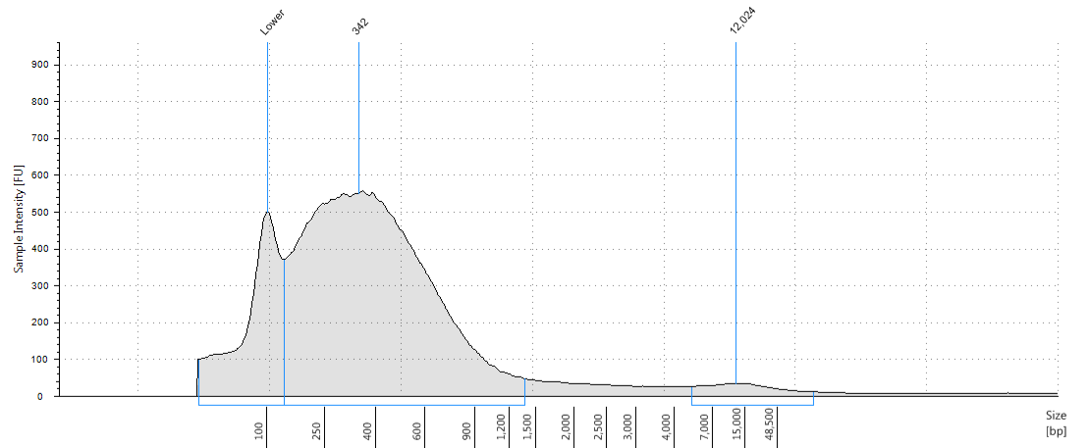
105

Peak Table
Size [bp] | Calibrated Conc. [ng/µl] | Assigned Conc. [ng/µl] | % Integrated Area | Peak Comment | Observations | From [bp] | To [bp]
100 | 8.50 | 8.50 | - |  | Lower Marker | 34 | 130
342 | 35.4 | - | 96.87 |  |  | 130 | 1,370
12,024 | 1.14 | - | 3.13 |  |  | 5,108 | >60000

B2
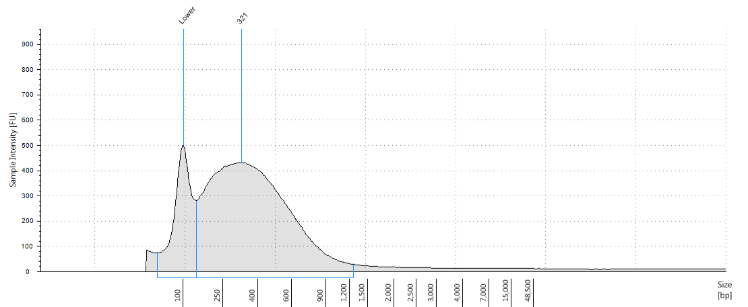
106

Peak Table
Size [bp] | Calibrated Conc. [ng/µl] | Assigned Conc. [ng/µl] | % Integrated Area | Peak Comment | Observations | From [bp] | To [bp]
100 | 8.50 | 8.50 | - |  | Lower Marker | 54 | 136
321 | 33.9 | - | 100.00 |  |  | 136 | 1,257

C2
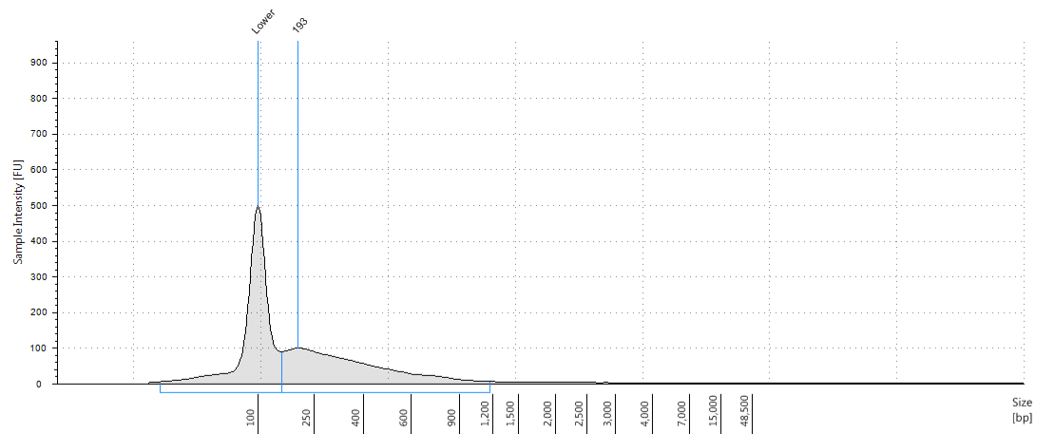
108

Peak Table
Size [bp] | Calibrated Conc. [ng/µl] | Assigned Conc. [ng/µl] | % Integrated Area | Peak Comment | Observations | From [bp] | To [bp]
100 | 8.50 | 8.50 | - |  | Lower Marker | 20 | 147
193 | 6.91 | - | 100.00 |  |  | 147 | 1,168

D2
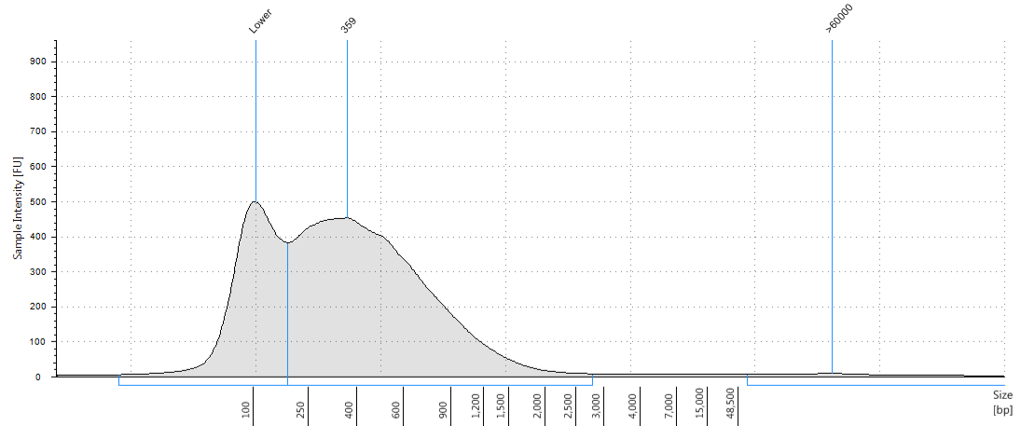

Peak Table
Size [bp] | Calibrated Conc. [ng/µl] | Assigned Conc. [ng/µl] | % Integrated Area | Peak Comment | Observations | From [bp] | To [bp]
100 | 8.50 | 8.50 | - |  | Lower Marker | 10 | 169
359 | 20.8 | - | 98.64 |  |  | 169 | 2,788
>60000 | 0.287 | - | 1.36 |  |  | 58,445 | >60000

